NAME: SIVARANJANII.M
DATE: 01.09.25 ROLL NO.:241901109

EXERCISE 6
IMPLEMENT PACKET SNIFFING USING RAW SOCKETS IN PYTHON
PACKET SNIFFING:
Packet sniffing is the process of capturing and analyzing network data packets to monitor traffic, troubleshoot networks, or detect security issues.
AIM:
To develop a Python program using raw sockets that captures Ethernet frames and displays their Source MAC, Destination MAC, and Protocol information.
ALGORITHM:
- Get the host IP address.
- Create a raw socket and bind it to the host.
- Enable IP headers and promiscuous mode.
- Continuously receive packets from the network.
- For each packet
- Extract destination MAC, source MAC, and protocol.
- Convert them into human-readable format.
- Display the results.
CODE:
import socket
import struct
import binascii
import textwrap
def main():
# Get host
host = socket.gethostbyname(socket.gethostname())
print('IP: {}'.format(host))
# Create a raw socket and bind it
conn = socket.socket(socket.AF_INET, socket.SOCK_RAW, socket.IPPROTO_IP)
conn.bind((host, 0))
# Include IP headers
conn.setsockopt(socket.IPPROTO_IP, socket.IP_HDRINCL, 1)
# Enable promiscuous mode
conn.ioctl(socket.SIO_RCVALL, socket.RCVALL_ON)

while True:
# Recive data
raw_data, addr = conn.recvfrom(65536)
# Unpack data
dest_mac, src_mac, eth_proto, data = ethernet_frame(raw_data)
print('\nEthernet Frame:')
print("Destination MAC: {}".format(dest_mac))
print("Source MAC: {}".format(src_mac))
print("Protocol: {}".format(eth_proto))
# Unpack ethernet frame
def ethernet_frame(data):
dest_mac, src_mac, proto = struct.unpack('!6s6s2s', data[:14])
return get_mac_addr(dest_mac), get_mac_addr(src_mac), get_protocol(proto), data[14:]
# Return formatted MAC address AA:BB:CC:DD:EE:FF
def get_mac_addr(bytes_addr):
bytes_str = map('{:02x}'.format, bytes_addr)
mac_address = ':'.join(bytes_str).upper()
return mac_address
# Return formatted protocol ABCD
def get_protocol(bytes_proto):
bytes_str = map('{:02x}'.format, bytes_proto)
protocol = ''.join(bytes_str).upper()
return protocol
main()

OUTPUT:
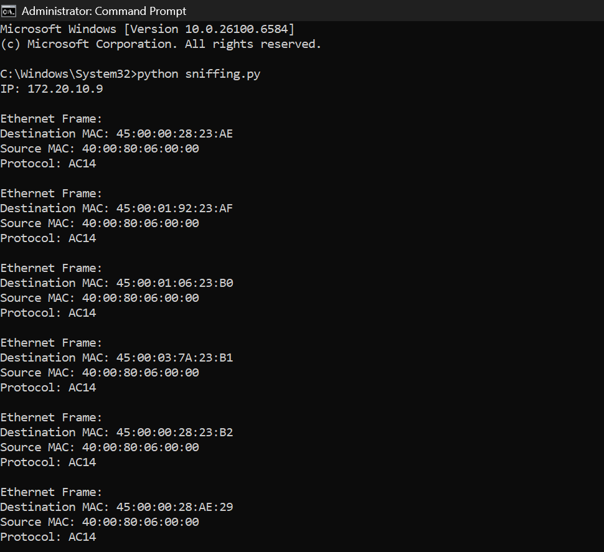

RESULT:
The program successfully captures network packets and displays their MAC addresses and protocol details, demonstrating basic packet sniffing functionality.

